Day2_Exercise_Assignment_Shintu Kumar

Assignment 1: Pseudocode and Flowchart for Sorting Algorithm - Write pseudocode and create a flowchart for a bubble sort algorithm. Provide a brief explanation of how the algorithm works and a simple array of integers to demonstrate a dry run of your algorithm.

Flowchart:

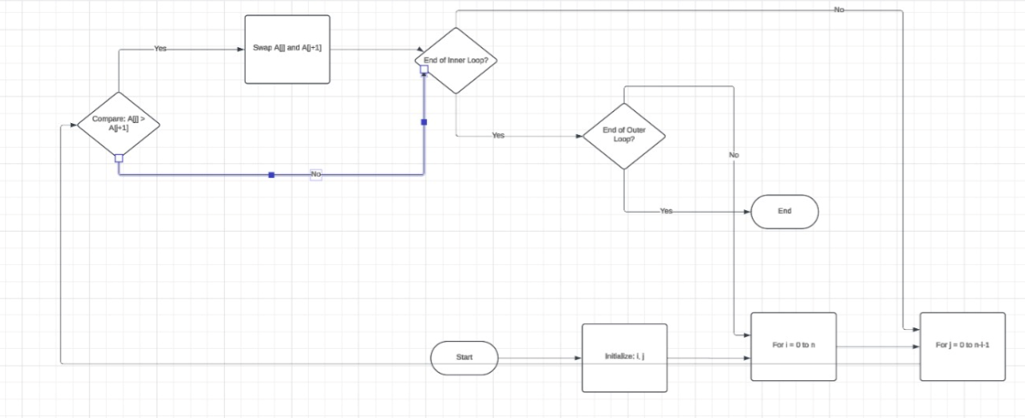

Pseudocode:

Start
accept array values from user

declare temp=0
declare n = array.length

for I range from 0 to n-1

for j range from 0 to n-i-1

if(arra[j] > arr[j+1])

temp = arr[j]
arr[j] = arr[j+1]
arr[j+1} = temp

End if
End loop
End

Assignment 2: Recursive Function and Efficiency Analysis - Write a recursive function pseudocode and calculate the nth Fibonacci number and use Big O notation to analyse its efficiency. Compare this with an iterative approach and discuss the pros and cons in terms of space and time complexity.

Start
Print "Enter number"
Input n

Call fibonacci(n) ---> fibonacci(int n)

Print result if(n==0 || n==1)
return 1
else
return fibonacci(n-1) + fibonacci(n-2)

Big o notation is used to analysis time and space complexity.
Big o notation for this recursive fibonacci series is (n^2).

Pro:-
- It is easy to code because code is divided into two small parts.

Cons:-
- Recursion can be slow.
- Uses more memory at run time

